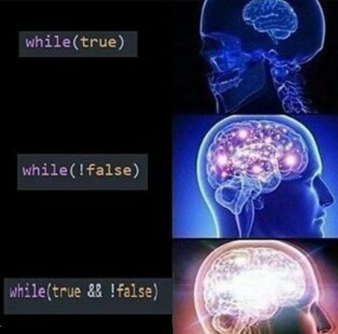

Project 2

BlackJack

Sergio Nuno | CSC-5 | June 5th,2018

# Table of Contents

Page ____What is my game?___________________________________________________2

Page ____Flowchart/Puesdocode______________________________________________3-15

# What is my game?

Black jack is a game know to be played in casinos all around the world. To win a game of balck jack, you need 2 things strategy and luck. The objective of the game is to get as close or 21 in order to win, the dealer tries to do the same.

* You are given 2 cards to begin with.
* You can decide to hit (draw another card) or play with the cards you have
* Each care has a numeric value. Number cards equaling their number, Jacks, Queens, Kings equaling 10, and in my version Ace is only equal to 11.
* Example, you are given a 2 of aces and a queen of spades those 2 cards equal up to 12 at this point you would want to take another card to get close to 21.

## FLowchart

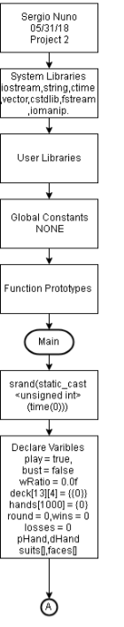Pseudocode here.

*Opening Comments*

*System Libraries*

*Function Prototypes*

*Main*

*Set random number seed*

*Declare Variables*

*Whi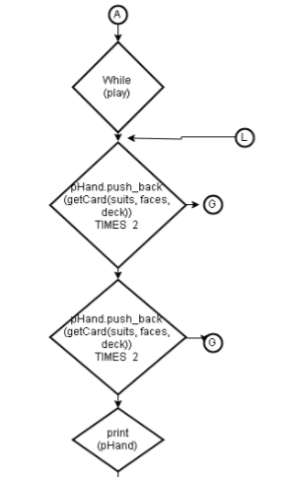le loop*

*Calls function getCard Two times for player’s hand*

*Calls function getCard Two times for dealer’s hand*

*Calls function print to display pHand*

*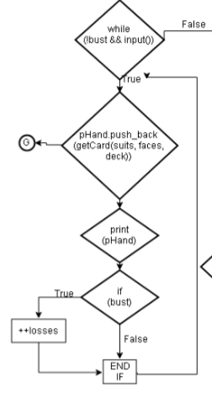While loop*

*True*

*Call function get card*

*Calls function print to display hand*

*If statement*

*True number losses increment*

*False if statement ends*

*While Loop ends*

*If 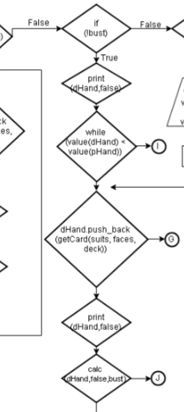statement false*

*If the player did not bust*

*Call function print to make dealer hand bust*

*While loop*

*Calls function value to determine who won*

*Calls function getCard*

*Calls function print to display that dealers hand*

*Calls function calc to declare bust*

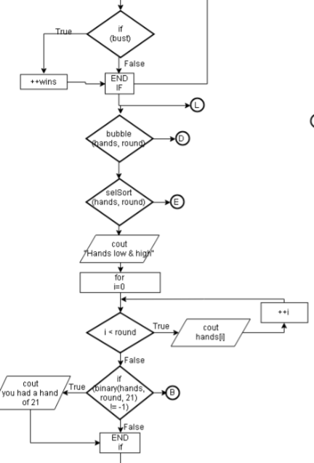

*If statement*

*True win is added*

*End if statement*

*Call bubble sort*

*Call selection sort*

*Output hands high and lows*

*For loop*

*Output the hand that you had at the end of each round*

*If statement*

*Calls function binary*

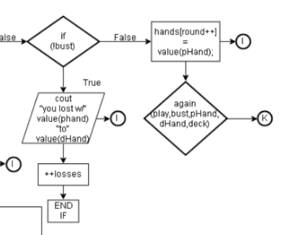

*If statement*

*If you busted*

*Output your hand and dealers hand*

*Add loss*

*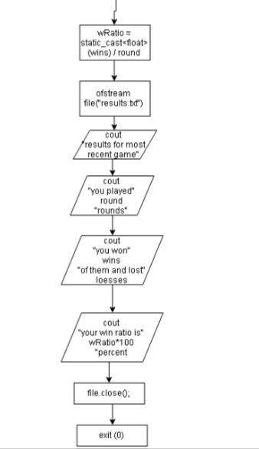End if statement*

*Average rounds won*

*Ouput results to txt file*

*Outputs data*

*To*

*Text*

*File*

*Close file*

*Exit program*

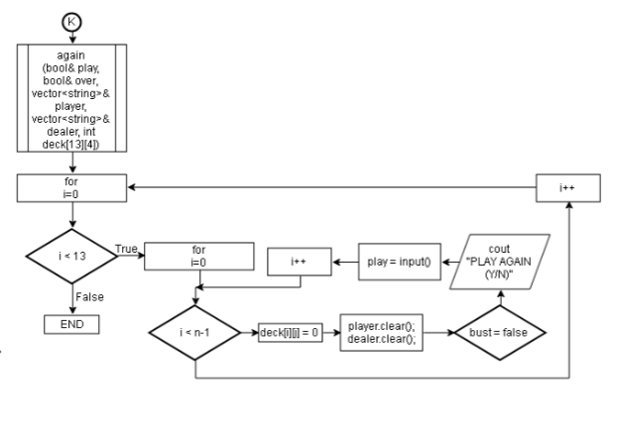

*Again function*

*Decides if you want to play the game*

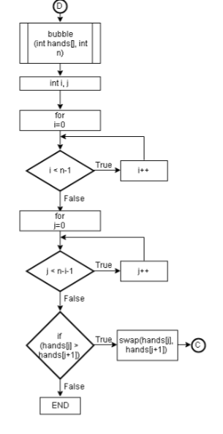

*Bubble sort sorts all the cards at the end of the*

*Game to know what your highest and*

*lowest hands were*

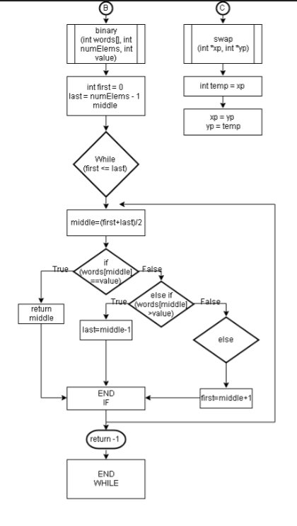

*Binary sort and swap*

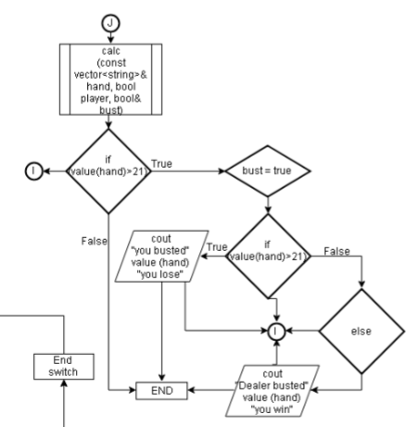

*Calculation function*

*Calculates is your hand*

*Vs the dealers hand*

*Is a bust or not*

*As well as outputs that data*

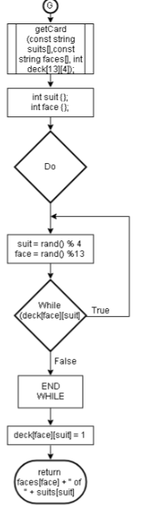

*Get card function*

*This function*

*Outputs your hand of cards to both*

*Plater and dealer*

*Randomly with a 52 deck of cards*

*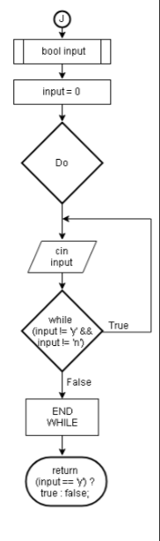Bool input*

*Decision function to decide if yes or no*

*Do while*

*Input input*

*While loop*

*End while loop*

*Print function*

*Prints out what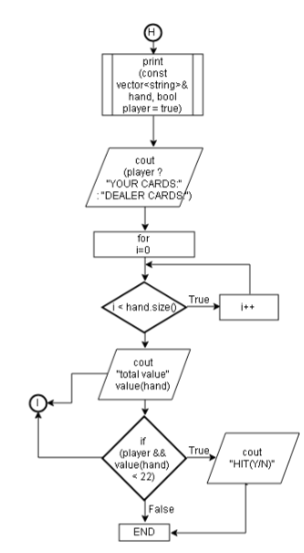 is the players hand value is*

*For loop*

*Cout*

*Total value of hand*

*If you want to add another card or not*

*End*

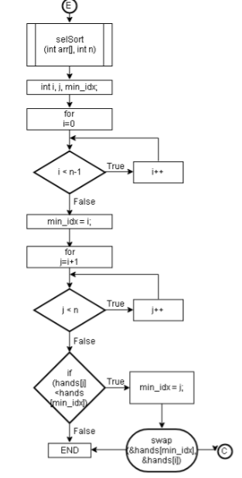

*Selection sort*

*Sorts all your previous hands and displaying them*

*High to low*

*For loop*

*For loop*

*If statement*

*Swap function called*

*End*

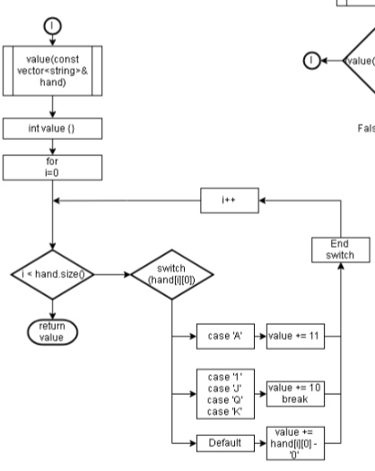

*Value function*

*Makes up the card values*

*For loop*

*Switch statement*

*Return value*